Table of Content
1 Context 2
1.1 Applicant Organisation 2
1.3 Legal Representative 2
1.4 Contact Person 3
1.5 Background 3
2 EBBD Quality Standards 3
2.1 Learning Units and Learning Outcomes 4
2.2 Transversal Skills (European Frameworks) 5
2.3 Technical Requirements 6
2.4 Confirmation of the applicant 9
3 Management 9
4 Implementation of the EBBD portfolio 9
4.1 Learning Units 9
4.2 Technical Requirements 15
5 Annexes 16
6 Checklist 17

Context
Welcome to the application form for EBBD accreditation.
Before starting, we advise you to read through the whole application form to understand it better.
You should also make sure to read the EBBD portfolio and guidelines carefully. You can find them here: EBBD portfolio (Link) and guidelines (Link)
Your application will be evaluated by the verifier responsible for your country. By selecting your country (see dropdown menu below), the application will automatically be forwarded to the responsible verifier.
As EBBD is an international qualification, applications need to be handed in in English.
For a list of contact information of all verifiers, please consult the following page: https://eurobacdiploma.eu/contact/

1.1 Applicant Organisation
To complete this section, you will need your organisation’s number (OID). Since 2019, the Organisation ID has replaced the Participant Identification Code (PIC) as unique identifier for actions managed by the Erasmus+ National Agencies.
As EBBD is a European Qualification based on the implementation of multilingual and multicultural activities and mobility, each organisation applying for EBBD has to prove that it is internationally active following the European objectives by providing an OID.
Organisation ID
Legal Name
Legal Name (National Language)
Address
Country
Postal Code
City
Website
Telephone
Fax

1.2 Legal Representative
Gender
First Name
Family Name
Position
Email
Telephone
EBBD coordinator | Yes/no selection

1.3 Contact Person
Gender
First Name
Family Name
Position
Email
Telephone
EBBD coordinator | Yes/no selection

1.4 Background
What is the size of your prospective EBBD programme?
Approximate number of students in the basic programme of your institution that is eligible for EBBD
Thereof approximate number of graduating EBBD students (if you are about to start, explain how you expect the number to develop)
Illustrate the European/International background of your organisation
Programme or initiative (e.g. Erasmus+) | Date, duration | (C) Coordinator  (P) Partner  (Dropdown) | Name of the project, brief description

2 EBBD Quality Standards
The Certificate of Excellence in European Business Behaviour and Democracyor “EBBD” enables students and adult learners having achieved or aiming at a general university entrance qualification to generate an economic focus throughout their training, thus providing them with additional qualifications in the fields of Economy, Europe and Mobility. These competences form a homogenous standard across Europe and will be accredited as Certificate of Excellence in European Business Behaviour and Democracy– EBBD, thus being a label of excellence, which is based on but goes beyond the respective national/regional curricula. The EBBD curriculum defines a graduate profile that can be developed in different manners in different national systems.
Organisations implementing EBBD must adhere to a common set of EBBD standards. The standards exist to ensure good learning outcomes for all EBBD students, and to make sure that all partners involved in the EBBD programme at your organization are contributing to this objective.
The EBBD quality standards are part of the EBBD portfolio. They are also presented below so you can read and easily access them again while writing your application.
Please read the EBBD quality standards presented below carefully and confirm your agreement.

2.1 Learning Units and Learning Outcomes

A unit of learning outcomes (LU) is a component of a qualification, consisting of a coherent set of knowledge, skills and competences that can be assessed and validated (for this and all following quotes in italics see the ECVET Recommendation 2009 - http://www.ecvet-secretariat.eu/en/faq-page#t2n969).
Units enable progressive achievement of qualifications through transfer and accumulation of learning outcomes. They are subject to assessment and validation that verify and record that the learner has achieved the learning outcomes expected.
Learning outcomes (LO) are statements of what a learner knows, understands and is able to do on completion of a learning process. LOs are defined in terms of knowledge, skills and competence. (see the 2008 Recommendation on the European Qualifications Framework - EQF).
Learning outcomes may be acquired through a variety of learning pathways, modes of delivery (school-based, in-company, workplaces etc.), in different learning contexts (formal, non-formal and informal) or settings (i.e. country, education and training system ...).

The European competence is to be seen as the core of the Diploma; the “roof” that covers everything else. The European competence comprises citizenship (including European Politics), intercultural competences and European Economics. As these learning units are the core of the EBBD, every college that wants to be accredited needs to give proof, that they cover these completely.
Under this roof special business competences that are crucial for any kind of business are taken into account, such as Marketing, Goods/Services (depending on the focus of each college), Procurement, Finances and Controlling as well as Human Resources. As EBBD is a European qualification the European/International perspective needs to be taken into account, whenever possible. Regarding accreditation each college needs to give proof of including the international perspective at least for three of the five business learning units.
The assessment of learning outcomes for each learning unit has to be based on a mix of at least three of the following instruments:
- exams/tests
- written assignments (presentations, essays, term papers, reports)
- oral presentations
- role plays
- observing the student’s work and behaviour and evaluating the results produced in different social forms (individual work, partner work, group work, internships, projects, junior enterprises, etc.)
As the emphasis is on the Learning Outcomes , the time dimension required in order to achieve them, can only be given approximately, depending on the destinctive characteristics of the educational system in the respective European country. If the focus of the educational system is on teaching lessons, the Learning Units equal a time dimension of approximately 960 lessons of 45 minutes or 720 lessons of 60 minutes. In countries where the focus is on the workload, taking into account teaching and own work of a student the workload is approximately 2,000 hours. However, the most important benchmark is that the students demonstrate to have achieved the learning outcomes described. This could also mean to recognise prior learning in non-formal and informal settings in adult learning.
According to the basic level of EBBD (EQF – level 4) the relevant (and minimal) proficiency level that needs to be achieved is level 4 in the framework (upper-intermediate), characterised by well-defined tasks and non-routine problems (complexity of tasks), that are solved independently and according to the learners needs (autonomously), thus demonstrating a profound understanding.
This does not exclude the option, that there might be competence areas and competences where the EBBD graduates have achieved a higher proficiency level including guidance of others, taking responsibilities for making decisions, etc.. This is particularly true for countries that provide the EBBD combined with Higher Vocational Education (EQF 5).

2.2 Transversal Skills (European Frameworks)
Regarding the constant and accelerated change in the Future of Work as stated in the report of the World Economic Forum in 2018, key competences for lifelong learning become more and more important. Or as the Council Recommendation of 22 May 2018 on key competences for lifelong learning states it:
“Nowadays, competence requirements have changed with more jobs being subject to automation, technologies playing a bigger role in all areas of work and life, and entrepreneurial, social and civic competences becoming more relevant in order to ensure resilience and ability to adapt to change. […] Consequently, investing in basic skills has become more relevant than ever. High quality education, including extra-curricular activities and a broad approach to competence development, improves achievement levels in basic skills. […] Skills such as problem solving, critical thinking, ability to cooperate, creativity, computational thinking and self-regulation are more essential than ever before in our quickly changing society. […] Non-formal and informal learning play an important role in supporting the development of essential interpersonal, communicative and cognitive skills such as critical thinking, analytical skills, creativity, problem solving and resilience that facilitate young people’s transition to adulthood, active citizenship and working life.”
As a consequence of this development EBBD puts a special focus on these key competences of lifelong learning and their fostering.
However, regarding business in an international setting as the field of learning of EBBD some key competences are emphasised more than others, especially multilingual competence, digital competence, entrepreneurship competence and cultural awareness and expression competence. Where the Digital Competence Framework for Citizens 2.0 and the EntreComp tackle some of these competences more specifically than the LLL-recommendations, EBBD refers to these frameworks instead.
The Council Recommendation of 22 May 2018 on key competences for lifelong learning provides further advice on how the development of key competences can be supported. Regarding the special design of EBBD the following learning approach and environment stated in the recommendation shall be particularly highlighted as a strength that distinguishes EBBD from other educational pathways:
“Specific opportunities for entrepreneurial experiences, traineeships in companies or entrepreneurs visiting education and training institutions including practical entrepreneurial experiences, such as creativity challenges, start-ups, student-led community initiatives, business simulations or entrepreneurial project-based learning could be particularly beneficial for young people, but also for adults and teachers. Young people could be given the opportunity to have at least one entrepreneurial experience during their school education.”
In order to support the development of these competences, it is necessary to provide a variety of learning approaches and environments as stated in the Council Recommendation of 22 May 2018 on key competences for lifelong learning.
As non-formal and informal learning is particularly relevant when developing key competences, it is not possible to establish assessment tools and an absolute benchmark as it was possible for the Learning Units. Therefore, other tools and instruments need to be implemented:
Regarding the Learning Outcomes of the mobilities, each EBBD college has to provide their EBBD students with the Europass Mobility.
Regarding transversal competences acquired in other contexts, each EBBD student shall manage an individual portfolio to document these. Examples of how this can be done are provided by the association for accredited colleges.

2.3 Technical Requirements
The Technical Requirements describe in which context the Learning Outcomes required for the EBBD qualifications should be acquired, applied and developed. Therefore, there is a close connection and an interaction between the Learning Units described above on the one hand, and the Technical Requirements on the other hand.
Foreign language competence plays a major role in attaining the EBBD qualifications, especially concerning their European and international orientation. Imparting foreign language competence follows the particular national rules of the respective educational institution offering EBBD.
The first foreign language shall be conveyed at B2 level and the second at B1 level of the CEFR. Within the European education systems, different languages are relevant as first respectively second foreign language – depending e.g. on geographical situations and traditions. Therefore, a specific foreign language is not stipulated in the EBBD portfolio. The definition of distinct, Europe-wide homogeneous language levels such as B2 resp. B1 CEFR guarantees that the required standards are met.
The Learning Outcomes described within the qualifications are to be acquired and demonstrated partly by Content and Language Integrated Learning – CLIL. This technical requirement results from the basic idea of the EBBD to offer students additional competences, especially in the areas, Economy, Europe and Mobility, thus qualifying them for the challenges of the European job market.
The standards in CLIL can be reached by means of school lessons within the extended scale of 180 lessons (in case of 60-minutes-lessons) and 240 lessons (in case of 45-minutes-lessons).
Apart from school lessons, CLIL can be acquired in work-based learning (WBL), if the first foreign language (B2) or the second foreign language (B1) is required and demonstrated. There may also be further possibilities, corresponding to the above mentioned, in order to gain the requested integrated content and foreign language competences. The respective workload is 500 hours.
With adult learners, CLIL can be acquired for example through taking part in business-related courses in a foreign language, or through intercultural work-related projects using a foreign language.
During the work placement abroad (students) or through work experience abroad (adult learners), learners demonstrate and develop their qualifications that were acquired in the context of training by applying them and putting them into practice. It is desirable that students use the foreign language competences they have acquired.
Work placements must take place in an organisation abroad within the field of Economics and Administration. Students have to be in different departments/working fields or in one department/working field doing different tasks.
Duration: Generally, four weeks (or longer, but not less than 3 weeks), If the time period is divided into sections, each section must take at least one week.
The work placement abroad is to be certified with a Europass Mobility certificate.
In exceptional cases a work placement can be completed within an internationally active local or national organisation. In this case students have to work or study abroad (not necessarily in the field of Economics and Administration) for a period of at least four weeks in addition to the work placement.
In some cases, the objectives of the work placement abroad can also be reached in other ways. This must be stated during the accreditation process and be accepted by the accreditation institution.
With adult learners, this requirement can be fulfilled through working within an internationally active company or organisation in the home country or abroad. There may also be further possibilities for adult learners to fulfil this requirement, e.g., through taking part in job-related or profession-related further education, training programmes or courses abroad.
This arrangement takes into consideration that there are significant national differences within the European education systems regarding organisational, curricular and financial factors.
Work-Based Learning, or WBL, encompasses a broad range of activities and activity types. However, it is accepted that each has a similar goal that centres on the acquisition of knowledge, skills and competences through action-based or reflective learning in a vocational or occupational context.
Terms might differ (for example, workplace learning, practice-based learning, work-centred learning) yet, in this context, we consider all such learning activities under the single heading of work-based learning.
From a strategic perspective, the provision of high-quality WBL lies at the heart of the current education and training policy, with education-industry collaboration regularly prioritised (at national and European levels) and WBL increasingly being recognised as a means of ensuring that learners of all ages are provided with the knowledge, skills and competences required by a future labour market.
In terms of delivery, WBL can take place onsite, in a company or organisation, or within a more traditional learning environment such as a classroom or training centre, the latter targeting learning that is vocationally or occupationally relevant and which centres on meeting the needs or expectations of a particular industry or profession.
To ensure successful delivery, WBL involves a wide variety of actors, ranging from those employed in more traditional learning environments such as schools, colleges, universities and training centres (teachers; trainers; tutors; classroom assistants) to managers and others in the workplace (Human Resources personnel; individual staff taking the role of mentors or advisors).
In addition to WBL in general it is important for EBBD to foster entrepreneurship in this context. The European Commission has developed EntreComp: the European Entrepreneurship Competence Framework, as a reference framework to explain what is meant by an entrepreneurial mindset. EntreComp offers a comprehensive description of the knowledge, skills and attitudes.
The following general descriptions of the different types of WBL shall give EBBD colleges a variety of options to choose from in order to promote WBL further. For each option we highlight the competences of the EntreComp that could be particularly fostered with this form of WBL.
In order to be accredited, each college has to give proof that they provide one WBL experience as on-the-job training and one WBL experience as a school-based programme.
Forms of WBL that are applicable for EBBD in detail (based on the WBL in Europe – Practices and Policy Pointers):
- On-the-job training periods in companies (internships, work placements, traineeships) that are incorporated as a compulsory (see work placement abroad) or optional element of VET programmes leading to formal qualifications.
- work-practice or work-experience
- voluntary work or voluntary activity in a workplace or work environment
- WBL that is integrated into a school-based programme, through on-site labs, workshops, kitchens, restaurants, junior or practice firms, simulations or real business/industry project assignments. The aim is to create "real life" work environments, establish contacts and /or cooperation with real companies or clients, and develop entrepreneurship competences.
- Learning Office
- Junior or Practice Firms
- Simulations
- Business/Industry Project Assignments
- Other (Besides these forms of WBL others are possible, such as structured company visits, ERP Software training courses, E-Commerce projects like setting up a webshop etc.)
Students acquire or have acquired a general university entrance qualification according to the regulations of the respective national or local education system relevant for the institution offering EBBD. Thus, the EBBD curriculum does not define standards for general university entrance qualifications.
With adult learners EBBD gives the graduate a possibility to strengthen his/her chances to be eligible for further training opportunities e.g., through being an “upgrade” of a general university entrance qualification the graduate may have already acquired.

2.4 Confirmation of the applicant
In order to apply for EBBD accreditation, your organisation must subscribe to the EBBD Quality Standards and accept to be evaluated based on those standards.
I have read and understood the above EBBD Quality Standards

I understand and agree that the EBBD Quality Standards will be used as criteria for the evaluation of this accreditation

3 Management
What will your management do in order to support and facilitate the EBBD Quality Standards, in particular the implementation at the college and the observation of the requirements regarding Learning Units, Transversal Skills and Technical Requirements?

Management support

Implementation of the EBBD portfolio

4.1 Learning Units
Please choose one of the following:
Focus of your educational system | Dropdown menu/options to fill in  - Lessons of XXX minutes  - Workload in hours  - skills demonstrations
You can still select another basis regarding the time dimension of a specific learning unit. The figures given there will then be transferred according to the relation between lessons and workload described above and compared to the total required with regard to the focus of your educational system.
Please describe the way you will implement the following EBBD Learning Units and how you will assess the Learning Outcomes the students have achieved.
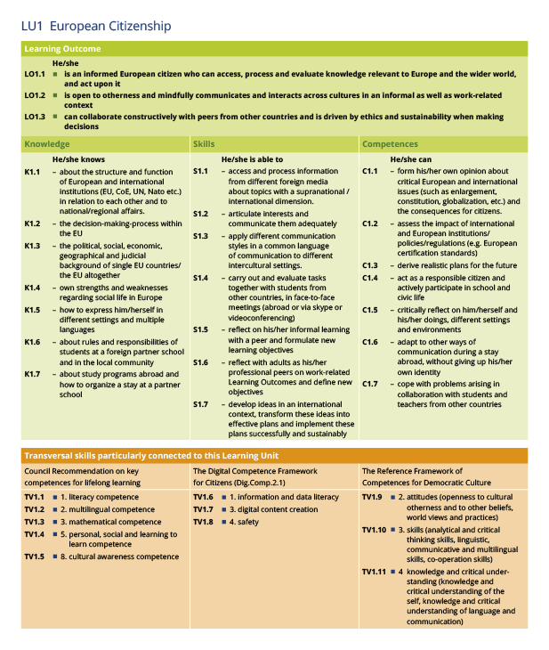

Best practice example for the format in which you can display the implementation of a Learning Unit at your colleges

Learning Unit 1  European Citizenship  (multiple selections possible) | Implementation via (dropdown menu)  - national curriculum  - additional school curriculum  - other (field for separate explanation)
Explanation how knowledge, skills and competences are acquired within the programme and which transversal skills are fostered in particular
Time dimension | Lessons | Work-load | Skills demonstration (mainly adults)
 | Approx. number | Approx. number | Form of demonstration
Assessment of the LO  (min. of 3) | Dropdown menu:  - exams/tests  - written assignments (essays, term papers, reports)  - oral presentations  - role plays  - observing the student’s work and behaviour and evaluating the results produced in different social forms (individual work, partner work, group work, internships, projects, junior enterprises, etc.)  - other: separate explanation
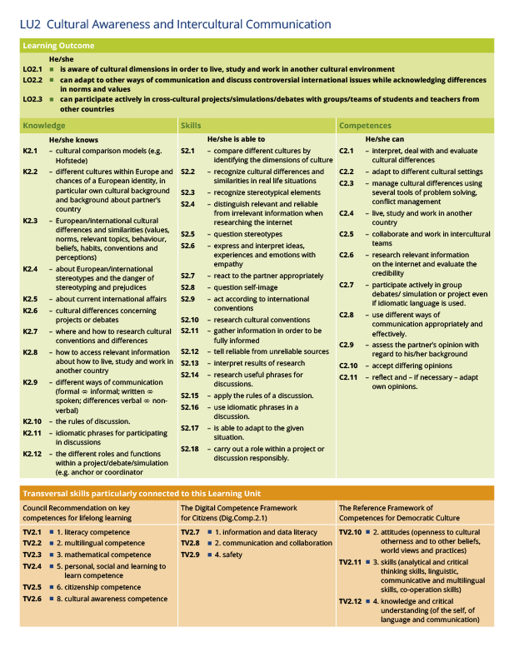
Learning Unit 2  Cultural Awareness and Intercultural Communication  (multiple selections possible) | Implementation via (dropdown menu)  - national curriculum  - additional school curriculum  - other (field for separate explanation)
Explanation how knowledge, skills and competences are acquired within the programme and which transversal skills are fostered in particular
Time dimension | Lessons | Work-load | Skills demonstration (mainly adults)
 | Approx. number | Approx. number | Form of demonstration
Assessment of the LO  (min. of 3) | Dropdown menu:  - exams/tests  - written assignments (essays, term papers, reports)  - oral presentations  - role plays  - observing the student’s work and behaviour and evaluating the results produced in different social forms (individual work, partner work, group work, internships, projects, junior enterprises, etc.) x  - other: separate explanation
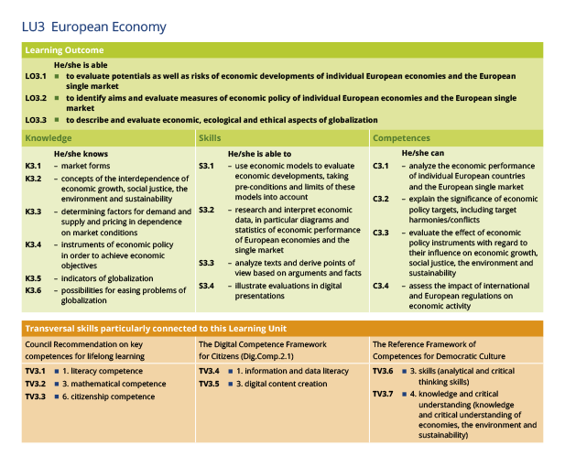
Learning Unit 3  European Economy  (multiple selections possible) | Implementation via (dropdown menu)  - national curriculum  - additional school curriculum  - other (field for separate explanation)
Explanation how knowledge, skills and competences are acquired within the programme and which transversal skills are fostered in particular
Time dimension | Lessons | Work-load | Skills demonstration (mainly adults)
 | Approx. number | Approx. number | Form of demonstration
Assessment of the LO  (min. of 3) | Dropdown menu:  - exams/tests  - written assignments (essays, term papers, reports)  - oral presentations  - role plays  - observing the student’s work and behaviour and evaluating the results produced in different social forms (individual work, partner work, group work, internships, projects, junior enterprises, etc.)  - other: separate explanation
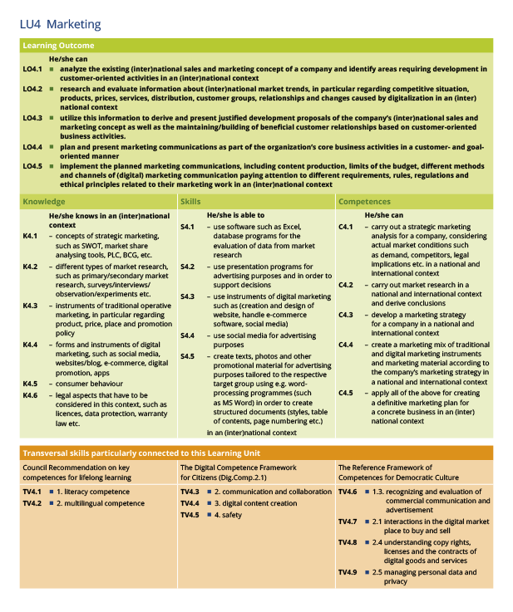
Learning Unit 4  Marketing  (multiple selections possible) | Implementation via (dropdown menu)  - national curriculum  - additional school curriculum  - other (field for separate explanation)
International Dimension | To be ticked off: Yes/no
Explanation how knowledge, skills and competences are acquired within the programme and which transversal skills are fostered in particular
Time dimension | Lessons | Work-load | Skills demonstration (mainly adults)
 | Approx. number | Approx. number | Form of demonstration
Assessment of the LO  (min. of 3) | Dropdown menu:  - exams/tests  - written assignments (essays, term papers, reports)  - oral presentations  - role plays  - observing the student’s work and behaviour and evaluating the results produced in different social forms (individual work, partner work, group work, internships, projects, junior enterprises, etc.)  - other: separate explanation
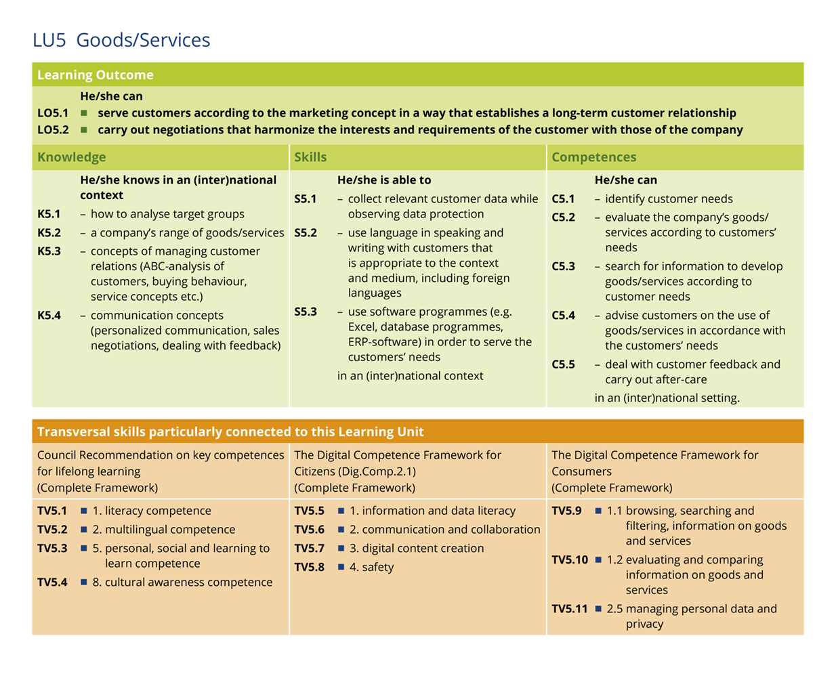
Learning Unit 5  Goods and Services  (multiple selections possible) | Implementation via (dropdown menu)  - national curriculum  - additional school curriculum  - other (field for separate explanation)
International Dimension | To be ticked off: Yes/no
Explanation how knowledge, skills and competences are acquired within the programme and which transversal skills are fostered in particular
Time dimension | Lessons | Work-load | Skills demonstration (mainly adults)
 | Approx. number | Approx. number | Form of demonstration
Assessment of the LO  (min. of 3) | Dropdown menu:  - exams/tests  - written assignments (essays, term papers, reports)  - oral presentations  - role plays  - observing the student’s work and behaviour and evaluating the results produced in different social forms (individual work, partner work, group work, internships, projects, junior enterprises, etc.)  - other: separate explanation
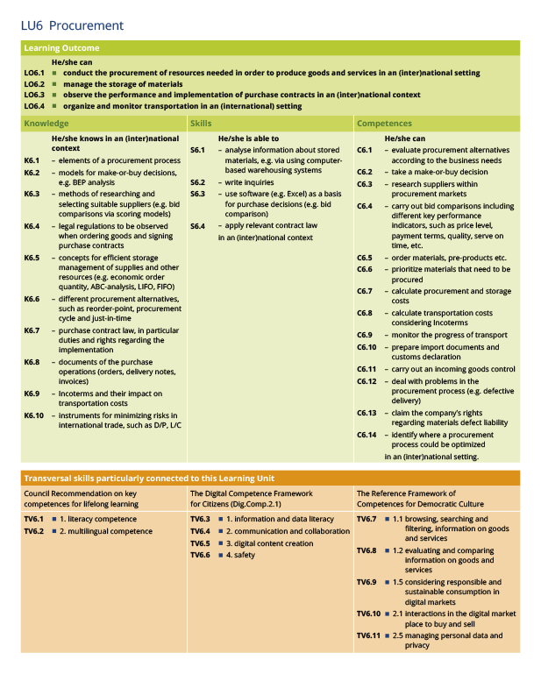
Learning Unit 6  Procurement  (multiple selections possible) | Implementation via (dropdown menu)  - national curriculum  - additional school curriculum  - other (field for separate explanation)
International Dimension | To be ticked off: Yes/no
Explanation how knowledge, skills and competences are acquired within the programme and which transversal skills are fostered in particular
Time dimension | Lessons | Work-load | Skills demonstration (mainly adults)
 | Approx. number | Approx. number | Form of demonstration
Assessment of the LO  (min. of 3) | Dropdown menu:  - exams/tests  - written assignments (essays, term papers, reports)  - oral presentations  - role plays  - observing the student’s work and behaviour and evaluating the results produced in different social forms (individual work, partner work, group work, internships, projects, junior enterprises, etc.)  - other: separate explanation
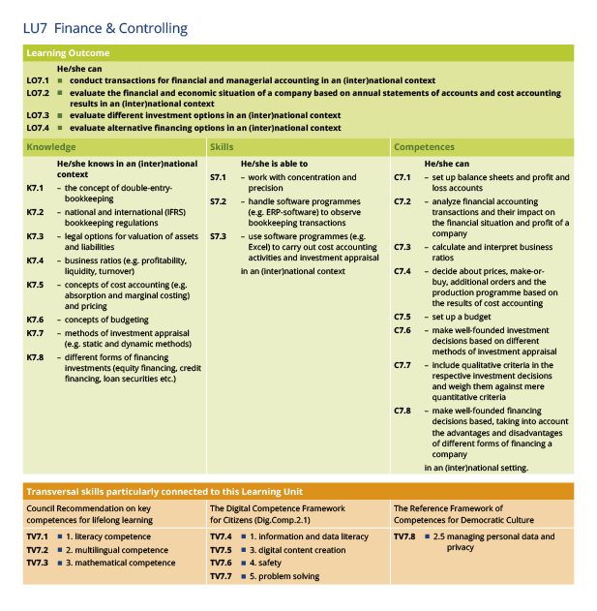
Learning Unit 7  Finance and Controlling  (multiple selections possible) | Implementation via (dropdown menu)  - national curriculum  - additional school curriculum  - other (field for separate explanation)
International Dimension | To be ticked off: Yes/no
Explanation how knowledge, skills and competences are acquired within the programme and which transversal skills are fostered in particular
Time dimension | Lessons | Work-load | Skills demonstration (mainly adults)
 | Approx. number | Approx. number | Form of demonstration
Assessment of the LO  (min. of 3) | Dropdown menu:  - exams/tests  - written assignments (essays, term papers, reports)  - oral presentations  - role plays  - observing the student’s work and behaviour and evaluating the results produced in different social forms (individual work, partner work, group work, internships, projects, junior enterprises, etc.)  - other: separate explanation
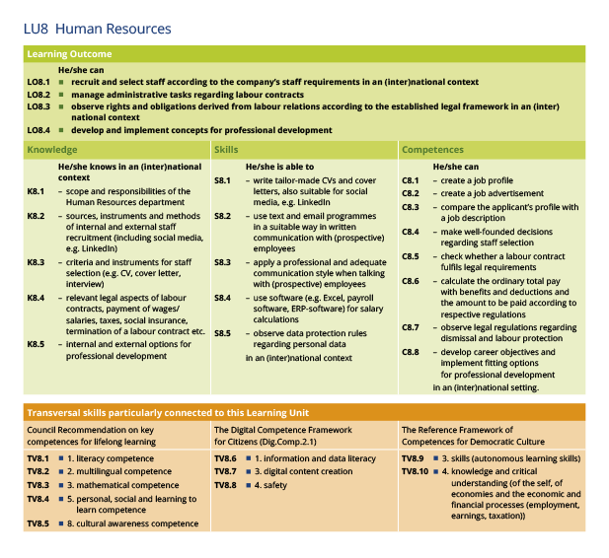
Learning Unit 8  Human Resources  (multiple selections possible) | Implementation via (dropdown menu)  - national curriculum  - additional school curriculum  - other (field for separate explanation)
International Dimension | To be ticked off: Yes/no
Explanation how knowledge, skills and competences are acquired within the programme and which transversal skills are fostered in particular
Time dimension | Lessons | Work-load | Skills demonstration (mainly adults)
 | Approx. number | Approx. number | Form of demonstration
Assessment of the LO  (min. of 3) | Dropdown menu:  - exams/tests  - written assignments (essays, term papers, reports)  - oral presentations  - role plays  - observing the student’s work and behaviour and evaluating the results produced in different social forms (individual work, partner work, group work, internships, projects, junior enterprises, etc.)  - other: separate explanation

Total:

Number of Learning Units 4 - 8 implemented with international context (min. 3) | Automatically added up based on ticks above → Green and accepted, when at least 3

Lessons/workload  Minimum of  - 720 lessons of 60 minutes (lessons of different length are automatically converted by the programme)  - 2000 hours workload | Automatically added up based on ticks/data given above → Green and accepted, when minimum requirements are fulfilled

4.2 Technical Requirements

First Foreign Language | Englisch
Level students acquire  Min. B2 | Dropdown menu:  - B2  - C1  - C2
Explanation how the first foreign language is acquired and how it is taken care of, that the students fulfil the required level

Second Foreign Language | French or Spanish
Level students acquire  Min. B1 | Dropdown menu:  - B1  - B2  - C1  - C2
Explanation how the second foreign language is acquired and how it is taken care of, that the students fulfil the required level

CLIL | English
Explanation how CLIL is implemented in your EBBD programme
Time dimension  Minimum:  - 180 lessons of 60 minutes (lessons of different length are automatically converted by the programme)  - 500 hours workload | Lessons | Work-load | Skills demonstration (mainly adults)
 | Approx. number | Approx. number | Form of demonstration

Explanation how you embed the work placements abroad into your EBBD program.

In case, that you are making use of one of the possible exceptions due to the requirements of your educational system contact the verifier for your country and outline the reasons and the applicable exception in detail here
Time dimension  Minimum:  - 3 weeks | Dropdown menu:  - 3 weeks  - 4 weeks  - More: _________________ (exact duration)
Type of certification | Dropdown menu:  - Europass mobility  - Other: ______________

Explanation how you embed the WBL into your EBBD program and include the transversal skills of the EntreComp.

On-the-job training  (at least 1) | Dropdown menu:  - Work practice/ work experience (including internship abroad)  - Voluntary work/voluntary activity in a workplace or work environment  - Other: ___________
School-based programme  (at least 1) | Dropdown menu:  - Learning Office  - Junior/Practice Firm  - Simulation  - Business/industry project assignment  - Other:

How do your students acquire the General University Entrance Qualification? | Drop-down menu  - Previously acquired  - Acquired through our organisation’s educational programme  - Acquired in combination with other educational qualifications, e.g., university entrance exams  - Other: _______________________________

5 Annexes
The maximum number of all attachments is 10. The maximum size of one file is 15 MB (?) and the total size of all attachments is 100 MB (?)

Please download the EBBD Declaration of Honour, print it, have it signed by the legal representative, and attach it here.

File Name

Please attach your description of the implementation of work placements abroad and the work-based learning in your EBBD programme

File Name

File Name

Please attach any other relevant documents that you have referred to you in your application. Please use clear file names.

File Name

x

File Name

6 Checklist
Before submitting your application form to EBBD e.V., please make sure that:

It fulfils all of the criteria defined by the EBBD portfolio

All relevant fields in the application form have been completed

Protection of Personal Data

Please read our privacy statement to understand how we process and protect your personal data (Link)

I agree with the Specific Privacy Statement on Data Protection

http://www.ecvet-secretariat.eu/en/faq-page#t2n969
In some countries accredited EBBD colleges can only formally acknowledge qualifications on EQF level 4 due to their NQF. However, by implementing EBBD at these colleges and observing the EBBD standards, i.e. exceeding the national qualification demands on that level, EBBD graduates acquire – at least with regard to some Learning Outcomes (defined by knowledge, skills and competences) – a higher level, that equals EQF level 5.
Council Recommendation of 22 May 2018 on key competences of lifelong learning.
https://www.wbl-toolkit.eu/index.php?id=13
https://www.skillsforemployment.org/KSP/en/Details/?dn=WCMSTEST4_057845
In case your institution is allowed to implement one of the exceptions mentioned attach the respective description

